Scott Ortolano

Professor of English

Edison State College

SOrtolano@Edison.edu

(239) 489-9472

Note to the Editors: My definition is 37 words over the 300 word cap. If this is a problem, please just let me know, and I will reduce the definition. As per the guidelines, I included images and hyperlinks wherever possible. The hyperlinks can be found in the section that lists further readings. All of the texts that I provide links to are out of copyright and located on .org websites. I also include a link to the New York Museum of Modern Art's page on Surrealism, which has a small gallery of paintings. If these links are not suitable, just let me know, and I will remove them and adjust the further reading section accordingly. The suggestions for further reading are annotated but these can be removed without any trouble.

**Surrealism**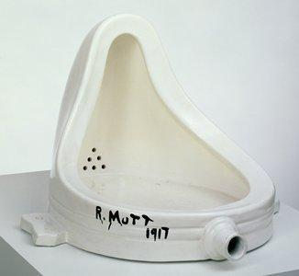

Surrealism emerged as a movement with André Breton and Philippe Soupault's publication of *Manifeste du Surréalism* in 1924. Rising in the wake of the First World War, Surrealism revolted against a world that had become deadened by habit, cliché, and scientific rationality. The movement was an offshoot of Dada, which emerged in Zurich in 1916. Dadaism and Surrealism both created work that mocked and insulted bourgeois aesthetic, moral, and social norms. However, Dada held that all ideals were inherently absurd and substituted nothing for the norms it ridiculed. Surrealism instead drew upon Sigmund Freud's belief that a primal, non-rational Id lurked beneath our rational intellect and idealized the creative potential of the subconscious.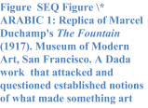

Surrealists dedicated themselves to collapsing the barrier between the dreaming and waking worlds. They developed techniques to suppress their rational intellect and tap into unconstrained consciousness. Using automatism, artists and writers worked in a trance-like state without interruption or later revision as a means of producing unfiltered art. Surrealists also emphasized collaboration and chance occurrence. This produced techniques like the exquisite corpse, in which individuals took turns drawing figures or writing lines while simultaneously obscuring preceding sections of text or the image. Furthermore, because of their interest in non-rational states of being, Surrealists idealized those who lived outside the bounds of traditional society. Breton famously said that "beauty will be convulsive or will not be at all," and this revolutionary spirit helped to reenergize fields that had largely reached a state of decadence. 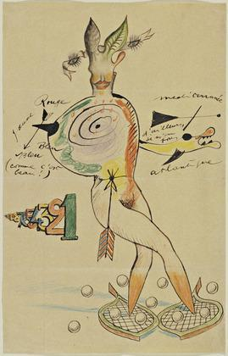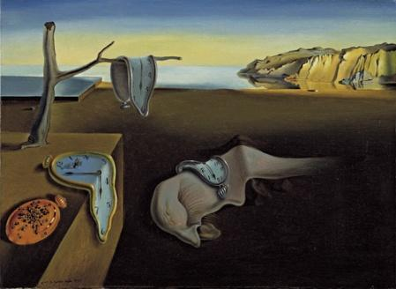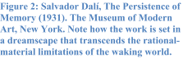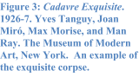

For further reading, please consult the following works:

Antonin Artaud. *The Theater and Its Double.* 1938. Trans. Mary Caroline Richards. New York: Grove Press, 1958. Print. This text applies Surrealist principles to the theater and details the Theater of Cruelty as a mode of jolting the audience from their malaise and breaking from a tradition that had become stultified.

André Breton "The Automatic Message." 1933. André Breton, Paul Eluard, and Philippe Soupault. *The Automatic Message; The Magnetic Fields; The Immaculate Conception*. Trans. David Gascoyne, Antony Melville, and Jon Graham. London: Atlas Press, 1997. In this landmark essay, Breton provides an overview of different types of Automatism. The collection referenced here is especially useful for those with an interest in the topic because the two other works are well-known examples of automatic writing.

--- and Philipe Soupault. [*Manifeste du Surréalism*](http://www.391.org/manifestos/1924breton.htm). Paris, 1924. First manifesto of the movement. This document provides a clear overview of the movement and its aspirations.

---. *Nadja*. 1928. Trans. Richard Howard. New York: Grove Press, 1960. This is an example of a Surrealist novel and also contains a useful explication of Breton's aesthetic ideals. Breton's quote at the end of the definition is drawn from the end of this novel.

Dalí, Salvador. “The Stinking Ass.” 1932. *Surrealist Painters and Poets: an Anthology*. Trans. J. Bronowski. Ed. Mary Ann Caws. Cambridge, MA: MIT Press, 2001. An essay that explicates Dalí's paranoiac-critical method, in which he entered into a trancelike state and was able to creatively misread the world as someone who is paranoiac or mad would. This produced what Dalí called a double-vision, where objects became separate from their rational order and took on a non-rational, double-meaning to the artist. This essay also provides an example of Surrealism's fascination with madness.

Sigmund Freud. [*The Interpretation of Dreams*](http://en.wikisource.org/wiki/The_Interpretation_of_Dreams). 1900. Trans. A.A. Brill. New York: Macmillan Company, 1913. Surrealists were captivated by Freud's theories of the primal subconscious and his belief that the subconscious could come to dominate the mind when the rational mind was weakened. Freud saw dreams as one such state, and Surrealists sought to join the dreaming and waking worlds.

Max Morise. "The Enchanted Eyes" *The Sources of Surrealism: Art in Context*. Ed. Neil Matheson. Burlington, VT: Lund Humphries, 2006. This is the first essay that discussed the application of Surrealism (as defined in the manifesto) to visual arts.

[Surrealism](http://www.moma.org/collection/details.php?theme_id=10203). The Museum of Modern Art. New York. 2010. This link provides a short overview of Surrealism in the visual arts as well as a small collection of paintings.

Tristan Tzara. [Dada Manifesto](http://www.391.org/manifestos/191804dadaist.htm). 1918. This manifesto provides an overview of Dada and its overarching ideals (or lack there of).